MIE1624: Introduction to Data Science and Analytics – Winter 2025 Project

### **Introduction**

The need for global innovation has become more pressing in light of recent global crises such as Russia's war against Ukraine, economic policies from the U.S. administration, and the ongoing effects of the COVID-19 pandemic. Innovation plays a crucial role in economic growth, global competitiveness, and national security. However, since the last major report in 2019, the landscape of innovation has changed significantly with the emergence of generative AI and evolving global policies.

This report aims to evaluate Canada’s standing in innovation relative to other countries, assess key factors driving innovation, and propose strategic improvements to enhance Canada’s innovation strategy. Our approach includes analyzing various data sources, developing a ranking system, and leveraging AI-based technology to extract insights from existing innovation strategies.

### **Part 1 – Collect data and summarize how innovations are measured**

For Part 1, we began by collecting public data from various sources on the development of innovation ecosystems in different countries and their respective innovation strategies. To gain deeper insights, we analyzed several YouTube videos that highlighted key factors influencing innovation. The first two videos focused on Canada’s innovation challenges and their impact on the economy. The first video, "The Economic Decline of Canada," discusses several contributing factors, including low GDP per capita, weak foreign investment due to excessive regulation, and insufficient spending on research and development (VisualEconomik EN, 2023). On the other hand, the competitive labor market from the US also causes high level professionals to leave the country. All of the factors contribute to the lack of innovation in Canada. The second video, *"*Most Educated, Least Productive: Why Canada’s Falling Behind,*"* reinforces these concerns, emphasizing Canada’s low R&D investment and declining productivity. However, it introduces an additional issue which is about labour composition. Despite a highly educated workforce, many individuals are employed in lower-skilled jobs, limiting innovation potential (CBC News, 2023). To broaden our perspective, we also examined the video "Why Is There No Silicon Valley in Europe?" Since Silicon Valley is the global center of technology and innovation, understanding why similar ecosystems have not emerged in Europe provides valuable context. The author pointed out that the silicon valley model is tied to labour flexibility, university industry connection and capital funds. However, there is a low investment in Research and development as well as military in Europe and there are many university Restrictions which leads to the low number of Unicorns in Europe (VisualEconomik EN, 2022). From these analyses, we can see that innovation is influenced by several economic and structural factors, including GDP per capita, the number of unicorn companies, R&D investment, regulatory policies, and workforce composition. These elements play a crucial role in shaping a country’s ability to foster and sustain innovation.

Next, we analyzed the European Commission’s report, ”The Future of Europe’s Competitiveness”, which outlines strategies to address the challenges Europe faces in maintaining its economic position (European Commission, 2023). The report emphasizes the need for increased investment to strengthen Europe’s industrial base and drive innovation. It also advocates for strategic trade partnerships, regulatory reforms, and improvements in the education system to bridge skill and innovation gaps. Furthermore many of the report’s recommendations align with the key factors identified in the videos we analyzed, such as the role of regulations, economic policies, and investment in fostering innovation. Additionally, its proposed solutions—such as promoting competition, aligning skills with job market needs, and reducing unnecessary regulations mirror those suggested in “Most Educated, Least Productive: Why Canada’s Falling Behind” (CBC News, 2023). This reinforces the idea that innovation ecosystems worldwide share common challenges and require similar solutions to thrive.

After analyzing the reports and videos, the next step is to conduct statistical analysis to develop a custom innovation score and examine key innovation factors in detail. To achieve this, we collected multiple datasets from various sources. The first dataset contains the Global Innovation Index, along with key features related to the index for each country from 2008 to 2021. The second dataset includes global GDP, GDP per capita, and annual growth rates from 1960 to 2020. This dataset is particularly valuable because, based on our prior research, economic factors such as GDP serve as strong indicators of innovation. In addition, we collected a dataset that lists unicorn companies worldwide, as the number of these high-value startups is another potential measure of innovation. We also incorporated two additional datasets that provide crucial indices for our analysis. The first is the Economic Freedom Index, provided by Heritage.org, which evaluates economic freedom in each country based on business regulations, trade policies, governance, and investment climate. According to the organization, countries with higher economic freedom tend to exhibit higher levels of innovation, entrepreneurship, and overall standard of living (The Heritage Foundation, 2021). This index also considers factors such as tax policies, investment freedom, and trade openness, making it a useful measure of country regulations which is one of the key drivers of innovation. The final dataset includes the Global Country Development and Prosperity Index, which assesses factors such as education, wealth distribution, governance, investment climate, and living conditions. Similar to the Economic Freedom Index, it serves as a strong indicator of a country’s standard of living and workforce quality, both of which are critical for fostering innovation. As previously discussed, workforce composition and job market competitiveness particularly the talent drain to the U.S have negatively impacted Canada’s innovation potential. This index helps quantify these effects, making it a valuable component of our analysis.

To create an effective custom score for ranking innovation across countries, the first step was to verify the variables in the dataset and analyze their relationships. The Global Innovation Index (GII) is one of the most widely recognized measures of innovation and was used as the primary benchmark for comparison. Skills demonstrated the highest correlation with the GII at 0.91, making it the most significant factor. ICT closely followed with a correlation of 0.89, while R&D had a correlation of 0.86, reinforcing its importance as a crucial innovation driver(Figure 1). In addition, GDP per capita from the global GDP dataset showed a correlation of 0.73 with the GII, further supporting the idea that economic prosperity contributes to innovation. The global prosperity and development index exhibited the strongest relationship with the GII at 0.92, while the economic freedom index demonstrated a correlation of 0.7, highlighting the role of economic policies in driving innovation.

To generate a meaningful ranking, principal component analysis (PCA) was applied to the dataset. PCA is a dimensionality reduction technique commonly used in data analysis to transform high-dimensional data into a set of uncorrelated principal components while preserving as much variance as possible. In this analysis, PCA was performed on all columns of the dataset to extract key innovation-driving factors and determine their relative importance. The principal components were weighted based on the proportion of variance each explained, ensuring that the most influential factors had a greater impact on the final ranking. The final innovation score was then derived as a weighted sum of the transformed variables, where each principal component was multiplied by its respective explained variance ratio. This approach ensured that the ranking accurately reflected the key dimensions of innovation, giving greater weight to variables that contributed most significantly to overall variance. The results of this analysis, displaying the ranking for the top 30 countries, are presented in Figure 2 of the appendix.

A key focus of this analysis was to assess Canada’s standing in innovation relative to other countries and to identify areas that require improvement. According to the 2024 Innovation Report Card, Canada ranked 15th among 20 countries, with 14 out of 21 indicators falling below average. The report identified weaknesses in R&D investment, productivity, and manufacturing, which are all critical components of innovation (The Conference Board of Canada, 2024). However, it also acknowledged that Canada performs well in areas such as education and research. These findings are consistent with observations from earlier video analyses, which highlighted similar strengths and weaknesses in Canada’s innovation landscape. The custom innovation score developed in this analysis ranked Canada 11th among other nations, suggesting that the country is performing relatively well (Figure 2). Specifically, Canada excels in ICT(0.9) and access to finance(0.87), which are recognized as key enablers of innovation. Figure 3 illustrates that Canada’s ICT sector has been on an upward trajectory. However, R&D investment and access to finance have shown a concerning downward trend in recent years, while other variables have fluctuated over time. To assess future trends, both linear regression and ARIMA models were applied to predict Canada’s Global Innovation Index (GII). The projections suggest a decline in innovation if current trends continue, highlighting the urgent need for policy reforms and strategic interventions (Figure 4). Further analysis of individual factor scores provided deeper insights into Canada’s innovation challenges. The country’s R&D score was measured at 0.6996, which is relatively low and aligns with concerns raised in multiple sources regarding insufficient investment in research and development. Additionally, workforce skills(0.737) and industry activity (0.765) were found to be below optimal levels, reinforcing previous conclusions that excessive regulation, low productivity and skill mismatches in the job market are hindering Canada’s innovation potential.

By summarizing findings from various reports, video sources, and data-driven rankings, this analysis identified the key drivers of innovation as R&D investment, government regulations, productivity, and workforce composition. While Canada performs well in access to finance, country development, education, and ICT, significant challenges remain in R&D investment, workforce skills, and productivity. To improve its innovation ranking, Canada must prioritize increasing investment in research and development, aligning workforce skills with job market demands, improving productivity and reducing restrictive regulations that hinder innovation. Addressing these challenges is essential for Canada to enhance its competitiveness and foster a more innovative economy in the years ahead.

Citations:

VisualEconomik EN. (2023, October 13th). *The economic decline of Canada* [Video]. YouTube.<https://www.youtube.com/watch?v=Nef1cLgEico>

CBC News. (2023, April 3rd). *Most educated, least productive: Why Canada's falling behind* [Video]. YouTube.<https://www.youtube.com/watch?v=xrR7PQOSnzo>

VisualEconomik EN. (2022, October 23rd). *Why is there no Silicon Valley in Europe?* [Video]. YouTube.<https://youtu.be/WNTtWYFhWus>

European Commission. (2023). *The future of Europe’s competitiveness: How to build a new European growth model* [Report]. European Commission. <https://commission.europa.eu/topics/eu-competitiveness/draghi-report_en>

The Heritage Foundation. (2021,March 10th). *2021 Index of Economic Freedom Intro Clip*[Video]. YouTube.<https://www.youtube.com/watch?v=CGv2ymqGznc&t=18s>

The Conference Board of Canada. (2024). *2024 innovation report card: Benchmarking Canada’s innovation performance* [Report]. The Conference Board of Canada. <https://www.conferenceboard.ca/product/innovation-report-card_2024/>

Appendix:

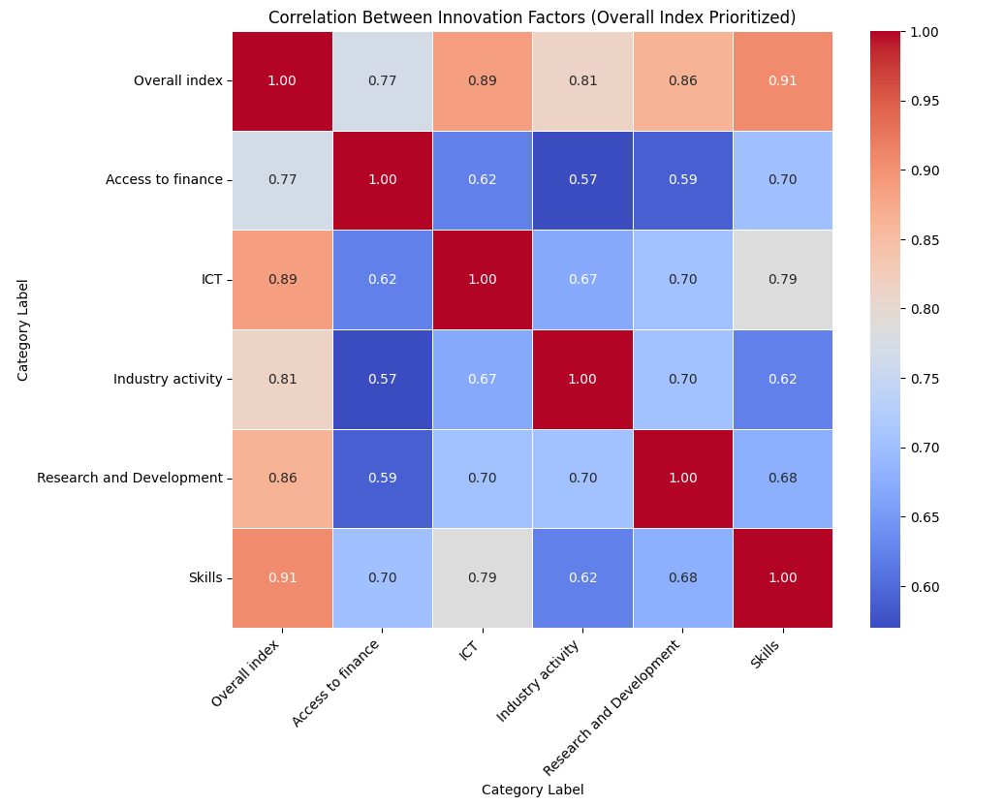

Fig 1: correlation between innovation factors in Canada

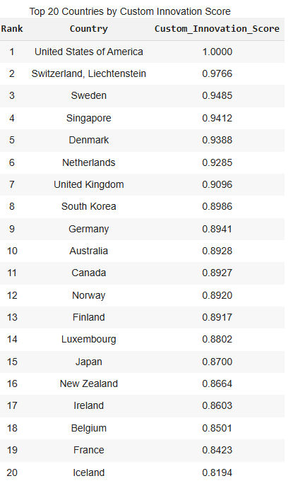

Figure 2: Custom score ranking of top 20 countries

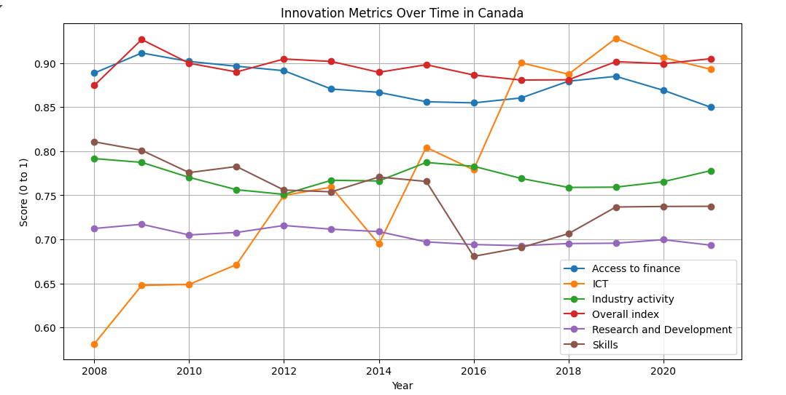

Fig 3: the changes in innovation factors over time in Canada

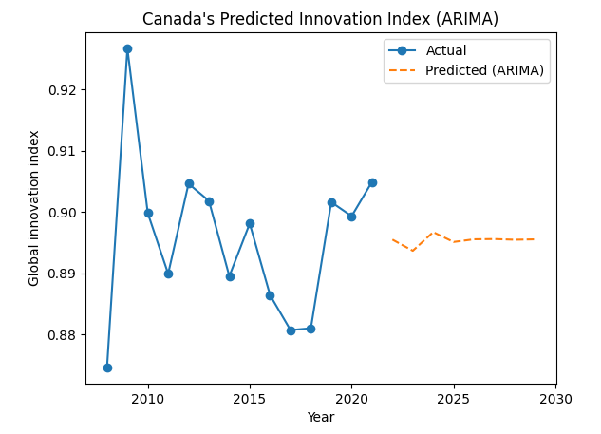

Fig 4: prediction of Canada’s GII using ARIMA